ASSIGNMENT – 6
- Create a abstract class Bank that has abstract method getROI(). Create two classes SBI, PNB, BOI inherited from Bank. Create a driver class that prints the rate of interest of each bank using super class memory reference.
Code:

abstract class Bank{
abstract double getROI();
}
class SBI extends Bank{
double getROI(){
return 10;
}
}
class PNB extends Bank{
double getROI(){
return 6;
}
}
class BOI extends Bank{
double getROI(){
return 7;
}
}
public class BankROI {
public static void main(String[] args) {
Bank b;
b = new SBI();
System.out.println("The Rate of Interest of SBI: " + b.getROI() + "%");
b = new PNB();
System.out.println("The Rate of Interest of SBI: " + b.getROI() + "%");
b = new BOI();
System.out.println("The Rate of Interest of SBI: " + b.getROI() + "%");
}
}
Output:
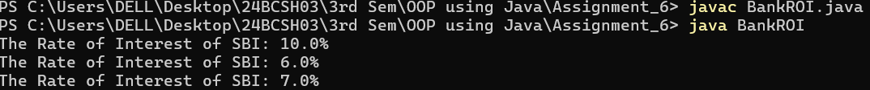
- Define an interface Calculator which has the basic methods add(), sub( ), mul() and div(). Define a concrete class named as DemoCalculator that implements the interface. Define the driver class, which create object reference of the interface Calculator and perform all basic operation of the calculator.
Code:
import java.util.*;
interface Calculator {
int add(int a, int b);
int sub(int a, int b);
int mul(int a, int b);
double div(int a, int b);
}
class DemoCalculator implements Calculator {
public int add(int a, int b) {
return a + b;
}
public int sub(int a, int b) {
return a - b;
}
public int mul(int a, int b) {
return a * b;
}
public double div(int a, int b) {
if (b == 0) {
System.out.println("Division by zero not allowed!");
return 0;
}
else
{
return (double) a / b;
}
}
}
public class calcopr {
public static void main(String[] args) {
Scanner sc = new Scanner(System.in);
System.out.print("Enter the value of a and b : ");
int a = sc.nextInt();
int b = sc.nextInt();
Calculator calc = new DemoCalculator();
System.out.println("The Addition is : " + calc.add(a,b));
System.out.println("The Subtraction is : " + calc.sub(a,b));
System.out.println("The Product is : " + calc.mul(a,b));
System.out.println("The Division is : " + calc.div(a,b));
sc.close();
}
}
Output:
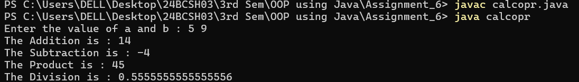

- Create an abstract class 'Shape' with three abstract methods namely 'RectangleArea' taking two parameters, 'SquareArea' and 'CircleArea' taking one parameter each. The parameters of 'RectangleArea' are its length and breadth, that of 'SquareArea' is its side and that of 'CircleArea' is its radius. Now create another class 'Area' containing all the three methods 'RectangleArea', 'SquareArea' and 'CircleArea' for printing the area of rectangle, square and circle respectively. Create an object of class 'Area' and call all the three methods.
Code:
import java.util.Scanner;
abstract class Shape{
abstract void RectangleArea(int length, int breadth);
abstract void SquareArea(int side);
abstract void CircleArea(int radius);
}
class Area extends Shape{
void RectangleArea(int length, int breadth){
double area = length*breadth;
System.out.println("The Area of the Rectangle is : " + area);
}
void SquareArea(int side){
double area = side*side;
System.out.println("The Area of the Square is : " + area);
}
void CircleArea(int radius){
double area = Math.PI*radius*radius;
System.out.println("The Area of the Circle is : " + area);
}
}
public class ShapeArea {
public static void main(String[] args) {
Scanner sc = new Scanner(System.in);
Area a = new Area();
System.out.print("Enter the Length and Breadth of the Rectangle: ");
int l = sc.nextInt();
int b = sc.nextInt();
a.RectangleArea(l, b);
System.out.println("Enter the Side of the Square : ");
int s = sc.nextInt();
a.SquareArea(s);
System.out.println("Enter the Radius of the Circle: ");
int r = sc.nextInt();
a.CircleArea(r);
sc.close();
}
}
Output:
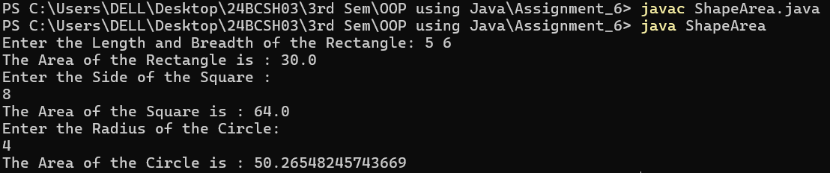

- Write a program to implement multiple inheritance using interface.
Code:
interface Sports {
void play();
}
interface Reads {
void read();
}
interface Writes {
void write();
}
class Student implements Sports, Reads {
public void play() {
System.out.println("The student is Playing.");
}
public void read() {
System.out.println("The Student is Reading.");
}
public void write() {
System.out.println("The Student is Writing.");
}
}
public class Interface {
public static void main(String[] args) {
Student s = new Student();
s.play();
s.read();
s.write();
}
}
Output:
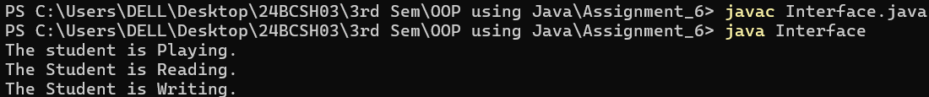

- Create an interface Servicing that has abstract methods getServiceTime(). Create two class Car, Bike that implement interface. Create a driver class that creates the objects of two class and displays the service time.
Code:
interface Servicing {
void getServiceTime();
}
class Car implements Servicing {
public void getServiceTime() {
System.out.println("The Service Time of the Car is : 5 hours");
}
}
class Bike implements Servicing {
public void getServiceTime() {
System.out.println("The service time of the Bike is : 2 hours");
}
}
public class ServTime {
public static void main(String[] args) {

Servicing car = new Car();
Servicing bike = new Bike();
car.getServiceTime();
bike.getServiceTime();
}
}
Output:
- Create a Package btech which has one class Student. Accept student detail through parameterized constructor of Student class. Write a method display()to display the student details. Create another class Test containing the main method which will use the package btech and calculate total marks and percentage of marks.
Code:
package btech;
public class Student {
int rollNo;
String name;
int m1, m2, m3;
public Student(int rollNo, String name, int m1, int m2, int m3) {
this.rollNo = rollNo;
this.name = name;
this.m1 = m1;
this.m2 = m2;
this.m3 = m3;
}
public void display() {
int total = m1 + m2 + m3;
double percentage = total / 3.0;
System.out.println("Roll_no : " + rollNo);
System.out.println("Name : " + name);
System.out.println("-----------MARKS-----------");
System.out.println("Sub 1 : " + m1);
System.out.println("Sub 2 : " + m2);
System.out.println("Sub 3 : " + m3);
System.out.println("Total : " + total);
System.out.println("Percentage: " + percentage);
}
}
import btech.Student;
import java.util.Scanner;
public class Test {
public static void main(String[] args) {
Scanner sc = new Scanner(System.in);
System.out.print("Enter Roll no: ");
int rollNo = sc.nextInt();
sc.nextLine();
System.out.print("Enter Name: ");
String name = sc.nextLine();
System.out.print("Enter 3 subject marks: ");
int m1 = sc.nextInt();
int m2 = sc.nextInt();
int m3 = sc.nextInt();
Student s = new Student(rollNo, name, m1, m2, m3);
s.display();
sc.close();
}
}
Output:
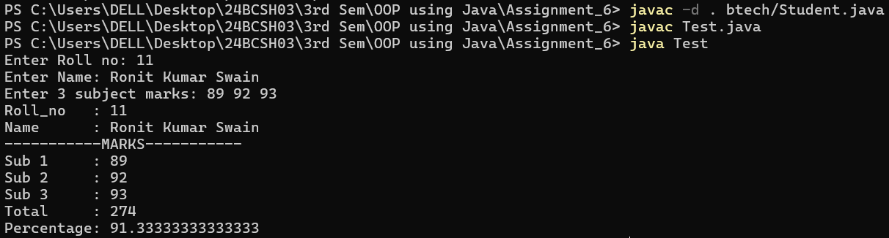

- Create a sub-package called arithmetic under the package btech. The arithmetic package should contain a class MyMath having methods to deal with different arithmetic operations (addition, subtraction, multiplication, division and mod). Create a class Test containing the main method which will use the methods of sub-package arithmetic.
Code:
package btech.arithmetic;
public class MyMath {
public int add(int a, int b) {
return a + b;
}
public int sub(int a, int b) {
return a - b;
}
public int mul(int a, int b) {
return a * b;
}
public double div(int a, int b) {
if (b == 0) {
System.out.println("Division by zero not allowed!");
return 0;
}
return (double) a / b;
}
public int mod(int a, int b) {
return a % b;
}
}
package btech;
import btech.arithmetic.MyMath;
import java.util.*;
public class Test1 {
public static void main(String[] args) {
Scanner sc = new Scanner(System.in);
System.out.print("Enter two Numbers : ");
int a = sc.nextInt();
int b = sc.nextInt();
MyMath m = new MyMath();
System.out.println("The Addition is : " + m.add(a, b));
System.out.println("The Subtraction is : " + m.sub(a, b));
System.out.println("The Product is : " + m.mul(a, b));
System.out.println("The Division is : " + m.div(a, b));
System.out.println("The Modulus is : " + m.mod(a, b));
sc.close();
}
}
Output:
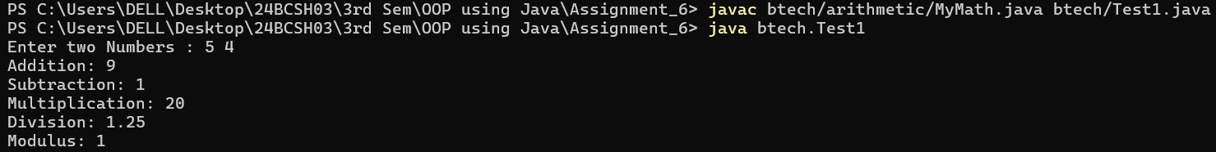

- Create a sub-package named shapesunder a package org. Create some classes in the package representing some common geometric shapes like Square, Triangle, Circle and so on. The classes should contain the area( ) and perimeter( ) methods in them. Compile the package. Use this package to find area and perimeter of different shapes as chosen by the user.
Code:
package org.shapes;
public class Square {
private double side;
public Square(double side) {
this.side = side;
}
public double area() {
return side * side;
}
public double perimeter() {
return 4 * side;
}
}
package org.shapes;
public class Triangle {
private double a, b, c;
public Triangle(double a, double b, double c) {
this.a = a;
this.b = b;
this.c = c;
}
public double area() {
double s = (a + b + c) / 2;
return Math.sqrt(s * (s - a) * (s - b) * (s - c));
}
public double perimeter() {
return a + b + c;
}
}
package org.shapes;
public class Circle {
private double radius;
public Circle(double radius) {
this.radius = radius;
}
public double area() {
return Math.PI * radius * radius;
}
public double perimeter() {
return 2 * Math.PI * radius;
}
}
import java.util.Scanner;
import org.shapes.Square;
import org.shapes.Triangle;
import org.shapes.Circle;
public class TestShapes {
public static void main(String[] args) {
Scanner sc = new Scanner(System.in);
System.out.println("Choose shape: 1.Square 2.Triangle 3.Circle");
int choice = sc.nextInt();
switch(choice) {
case 1:
System.out.print("Enter side of square: ");
double side = sc.nextDouble();
Square sq = new Square(side);
System.out.println("Area: " + sq.area());
System.out.println("Perimeter: " + sq.perimeter());
break;
case 2:
System.out.print("Enter sides of triangle (a b c): ");
double a = sc.nextDouble();
double b = sc.nextDouble();
double c = sc.nextDouble();
Triangle tr = new Triangle(a, b, c);
System.out.println("Area: " + tr.area());
System.out.println("Perimeter: " + tr.perimeter());
break;
case 3:
System.out.print("Enter radius of circle: ");
double r = sc.nextDouble();
Circle cr = new Circle(r);
System.out.println("Area: " + cr.area());
System.out.println("Perimeter: " + cr.perimeter());
break;
default:
System.out.println("Invalid choice");
}
sc.close();
}
}
Output:
